Oldswinford
Church of England Primary School

P.E. Policy



September 2022

Approved by the Governing Body: ( )

Signed- Chair of Governors:

Review: September 2024

Our School Vision
At Oldswinford Church of England Primary School we believe that there is a light which shines within each of us – a light that has been given to us by God, which we should use to help us achieve great things. We believe it is our job to help that light to shine in all that we do and all that we try to do.
Believe
‘Everything is possible for one who believes’
Mark 9:23
As a Church of England school we offer all children an invitation into the Christian faith, a chance for them to develop spiritually as well as intellectually, socially and morally. We want children to believe in their own abilities, to persevere when things are tough and we encourage them to aim high and follow their dreams. We want them to have the confidence to stand up to injustices and to make wise choices.
Achieve
‘Whatever you do, work at it with all your heart’ Colossians 3:23
We have high aspirations for all our learners and believe that every child should have the chance to reach their potential. We recognise that achievements come in many guises and we look to celebrate each child’s individual talents. We want to ensure our children are prepared for the next steps in their learning journey and they have all the skills they need to flourish and be happy.
Shine brighter together
‘Let your light shine for others, so they may see your good works’
Matthew 5:16
We believe that we all belong to one big family and each of us has a special part to play. We understand the need for our children to be responsible citizens especially when caring about our world and the people around us. As individuals we are unique and special but together, with God, we can be exceptional.
Our vision and 7 key Christian values of love, respect, trust, courage, forgiveness, generosity and joy enable us to ‘believe, achieve and shine brighter together’.

Whole School Intent for P.E.
At OCEPS, we provide a high-quality physical education curriculum, which is inspiring to all pupils and encourages them to succeed and excel in competitive sport and other physically-demanding activities. We provide opportunities for pupils to become physically confident in a way which supports their health and fitness. This is important because opportunities to compete in sport and other activities help to build self-esteem, character and help to embed values such as fairness and respect. At Oldswinford CE Primary School it is recognised that PE needs to build on the children’s natural enthusiasm for movement, by expressing and testing themselves in a variety of situations. Through physical education we aim to enable pupils to develop co-ordination, strength, stamina and skilfulness and to promote spatial awareness, intelligent reactions to situations and appreciation of physical excellence. We believe that Physical Education should lead to a sense of wellbeing, a greater understanding of health and fitness, a healthy lifestyle and a feeling of self-confidence.

Implementation of P.E.
OCEPS is a place where our teachers will:

- Ensure everyone feels included and valued.
- Encourage an ‘I can’ attitude.
- Help to develop confidence, self-belief and resilience.
- Celebrate achievements and those who are demonstrating resilience.
- Provide opportunities for children to develop their skills.
- Carry out carefully sequenced units of work which build on prior learning
- Provide extra-curricular activities to broaden children’s exposure and opportunities to a variety of sports.
- Provide opportunities for children to communicate and work as part of a team.
- Encourage children to, and set a good example of, leading healthy, active lives.
- Ensure children get the opportunity to share their talents.
- Help develop the children’s sense of responsibility towards their own and others safety and well-being.
Curriculum Planning & Whole School P.E. Outline
See Appendix 1 – whole school overview
See Appendix 2 – year group P.E. Progression documents

Organisation
- Children are taught two hours of PE each week, throughout the year the children are given the opportunity to experience a variety of indoor and outdoor activities.
- Hall time slots are available for each P.E. session, so that even if the weather is poor, the children can still enjoy their P.E. lesson.
- Swimming lessons take place in Year 5 at the Crystal Leisure Centre, which is delivered by specialist swimming teachers.
- Coaches from local sports agencies deliver lunchtime sessions and afterschool clubs every day
- Sports club sessions include, Multisport, archery, basketball, rugby, dance & much more throughout the year.
- Lunchtime clubs provide focussed activities for KS1 & KS2 with a regular different focus providing the children with a range of skill & game exposure.
- Year 5 work through the Playmaker Award during the autumn term. This enables them to experience how to teach sessions & deliver them with confidence.
- During the Spring term, our Year 5 P.E. Leaders (in small groups) then carry out lunchtime activities with the children & deliver P.E. lessons to children in KS1 helping them to develop their skills in their unit of work.
- Teaching staff deliver high quality lessons to the children using the GetSet4PE scheme.
- Children are then assessed at the end of each half term for their performance, social, emotional and thinking skills. This is done for each P.E. unit.
- At the end of each P.E. lesson, teachers deliver a plenary, allowing the children to reflect upon their performance and development of skills, identifying how these skills can be transferred to other areas of work and in life.

An outline of a P.E. lesson:
- Warm up – preferably to recap previous teaching if possible
- New skill learning that lesson shared with children (learning objective, along with S.E.T objective)
- Teacher to demonstrate skill
- Main activity showing progression, stopping the children to highlight children demonstrating the skill well and when necessary stopping to progress and show them next steps.
Teacher to be taking photos/videos during this.
- Children to recap key points from lesson
- Children to reflect and discuss during plenary
- Teacher to pick two children to award ‘P.E. superstar’ dojo points. One child for their success at the skill and one child for meeting the S.E.T objective(s).

P.E. Expectations for children
- Children come to school in their P.E. kits when it is their P.E. day, wearing the school uniform kit or red shorts and a red top, as well as appropriate footwear, such as pumps or black trainers. A dark coloured tracksuit/jogging suit and black trainers should be worn during the colder months.
- Children must have their hair tied back.
- All jewellery must be removed, including earrings (staff cannot remove these).
- Children try their best and persevere at the skill focusing on our growth mind-set and the power/magic of yet.
- Children to celebrate the successes of other children around them.
- Children to reflect and the end of the lessons through of a show of thumbs up/thumbs down.
- Children to self-assess on the I-pads at the end of each half term for each unit of P.E. taught.

Children who do not have their kit or cannot take part in P.E. will use one of the non-participant lanyards to help carry out activities/help support the children/teacher. This will be logged on P.E. Passport where it can be monitored. Class teachers should send reminders to parents about needing to come to school in P.E. kit on their P.E. days and remind parents of those days. The exception to this, is swimming, where children will be left in school with another class.
If children are failing to bring P.E. kit due to particular circumstances, then a P.E. kit may be purchased using Sports premium funding and kept in a labelled bag.

P.E. Expectations for staff
- It is expected that teachers change for P.E. or come to school dressed appropriately to deliver a high-quality lesson.
- Teachers to share the skill being taught during that lesson.
- Teachers to demonstrate the skill to the children and throughout highlight children who are demonstrating the skill well.
- Photos/videos should be taken during each lesson.
- Staff should award the ‘P.E. Superstar’ dojo to two children at the end of every lesson. This should be done during the plenary/reflection part of the lesson. We can then celebrate the successes of the two children. One child for their success at the skill and one child for showing the social, emotional and/or thinking skill(s). These children are also to be given Sports Star dojo points.
- Children to be assessed at the end of each half term for each unit of P.E. taught.

Extra-Curricular Links
P.E. links with many others areas and subjects within the National Curriculum. Staff also enjoy linking their themed topics to different areas of P.E. such as dance and gymnastics.
English
Links between P.E. and English include; writing sequences, following/giving instructions, oral/peer assessments, speaking and listening and movement within drama.

Maths
Links between P.E. and Mathematics include; measurement, shape and space, sequences, number, angles, position and movement, rotation and time, as well as problem solving.

ICT
Children have access to class I-pads to be able to capture photos/videos for evidence.

PSHE
PSHE and P.E. links include; following rules, leading and living a healthy lifestyle, co-operating with others and understanding fairness and equality. Pair work and group/team work help to enhance children’s personal and social skills.

Christian Values
Through sport children are taught and living out our school values, such as, respect, honesty, joy, love and courage. Children who are not participating also have access to a lanyard for the lesson that display one of these values. This allows the child to still participate in the lesson and display our school values too.

Science & Healthy Eating
Our curriculum teaches children about the physical changes in the body, the positive effects of exercise on the heart and body and how to eat a balanced diet.

Spiritual, Moral, Social and Cultural Development
P.E. offers many opportunities that support the social development of our children. Group/Team games allow the children to work together, encouraging and supporting one another to shine brighter together, and give them the chance to develop respect for the abilities of other children through collaborative and co-operative work, while gaining a better understanding of themselves.

Equal Opportunities & Inclusion
Activities are made available to all through differentiation and adaptation of activities during P.E. lessons. All children will be given the opportunity to achieve the objectives through a range of activities suitable to their needs. For competitions, all children will be given the opportunity to participate and experience these events.

Special Educational Needs & Disabilities
Any children identified as having ‘special educational needs’ are given the help that they require. They will take part in the P.E. lessons with the same exposure to the skills, but activities may be adapted to meet their needs, so that they can achieve an outcome and develop their skillset. For further advice and guidance, class teachers should consult with the SENCO and/or the PE lead.

External Providers
To increase opportunities to inspire children to be active, we have regular coaches from PureSport and ACE coaching. At lunchtimes, the coach offers a variety of activities and carries out after school clubs. Sports club sessions include, Multisport, archery, basketball & Cricket and many more throughout the year. All visitors/coaches have an up to date DBS to work in schools.

Active Playtimes
At lunchtimes, we have zoned areas, mainly on the top playground for KS2, to promote different types of physical activity and relevant equipment is provided to engage all children. During the spring term, Year 5 sports leaders will run activities during lunchtimes with the KS1 children. All year groups have their own lunchtime equipment box to help encourage them to be active and develop their skills.

Sports Day
At Oldswinford we love sports day and organise a whole school sports day, open to parents to come and view the races/activities and show their support. During sports day we usually have the ice cream truck from Mary Stevens Hospice attend the event and raise money for a good cause all whilst having fun. We award stickers to those children who win 1st, 2nd and 3rd place, but also celebrate the success of everyone, as it is the taking part that counts. These positions are given points, which then go towards our House Teams, St George, St Patrick, St David and St Andrew. The positions and winning house team are then announced to the rest of the school.

Leadership Opportunities
At Oldswinford we provide Year 5 with a special opportunity to work through the ‘Playmaker Award’. This enables them to experience how to teach P.E. sessions themselves & deliver them with confidence. During the Spring term, our Year 5 P.E. Leaders (in small groups) then carry out lunchtime activities with the children & deliver P.E. lessons to children in KS1 helping them to develop their skills within their P.E. units. This is a fantastic opportunity for these children and gives them a huge amount of confidence and a love of physical activity, even more so than before. It is something we are very proud to offer here at Oldswinford.

School Sports Premium
The school has a detailed plan to improve the quality of P.E. provision for all children. The plan includes an overview of sports premium spending and a review of the impact of the allocated funds. This can be found on the school website.

P.E. Resources
There is a wide range of resources to support the teaching of P.E. to enable children to achieve their objectives. These are mostly stored in the outdoor P.E. cupboard, which is labelled for ease of finding and returning equipment. The hall also contains large apparatus such as benches, mats, climbing apparatus and more, which we expect the children to help set up and put away safely with the help and supervision of a member of staff. At lunchtimes, the children play on the playgrounds and have year group boxes, with monitors, full of small equipment that the children can use to be active and play games with. During the summer months, children also have access to the field. Teachers are to ensure that all P.E. equipment is put away in the correct place and report any damaged equipment to the P.E. lead.

Assessment & Recording
Assessments are carried out by class teachers at the end of each half term for each unit of P.E. covered. This is recorded through the GetSet4PE, which tracks, performance, social, emotional and thinking skills.
Whilst teachers are carrying out P.E. lessons they are persistently assessing the children’s skills and making adaptations to help support the children. Photographs and videos are also taken during the lesson to show the children’s abilities.
Plenaries take place at the end of each lesson to ensure the children have understood their learning objectives, as well as their social, emotional and thinking objectives. This time also allows for the children to reflect and think deeper about what skills they have developed, why they are important and how they can be transferred to other learning and in their life.
The children are regularly asked about their P.E. lessons, allowing them to use their pupil voice to impact their learning.

Monitor & Review
The P.E. lead and a member of SLT are responsible for monitoring the quality and progression of P.E. and physical activity provision. The leader will support members of staff and share expertise, arrange opportunities for outside agencies to visit the school in order to enhance learning and direct teachers to examples of good practise. We monitor the progress of the children through the GetSet4PE scheme. We do this based on the teacher’s assessments, which highlights all children and their abilities, plus shows any areas of weakness which can then be addressed and further action taken to support.

Health and safety

It is the general teaching requirement for health and safety that applies to this subject taken from ‘Safe Practice in Physical Education and Sport’. We encourage the children to consider their own safety and the safety of others at all times. The class medical bag should be carried to the area where P.E. is taking place, containing relevant medical equipment and the snatch card. Teachers are expected to check all apparatus and the area P.E. is taking place for any potential health and safety issues and adapt their lessons/ or make the children aware before starting. Staff will also be aware of pupils who have special needs with regards to physical ability and make special provisions for needs where appropriate. P.E. equipment will also be stored and put away safely.

Impact
OCEPS is a place where our children will:

- Learn to communicate and work as part of a team.
- Develop competence to excel in a broad range of physical activities.
- Be given a broad range of opportunities to extend their agility, balance and coordination, individually and with others.
- Enjoy communicating, collaborating and competing with each other.
- Be physically active for sustained periods of time.
- Engage in competitive sports and activities.
- Develop flexibility, strength, technique, control and balance.
- Perform routines and compare them to improve and achieve their personal best.
- Be able to recognise their own success, as well as the success of others.
- Be a good team player and support their peers.
- Begin to learn to swim competently, confidently and proficiently.
- Lead healthy, active lives, with a good understanding of others and their well-being.
- Have fun!

Appendix 1
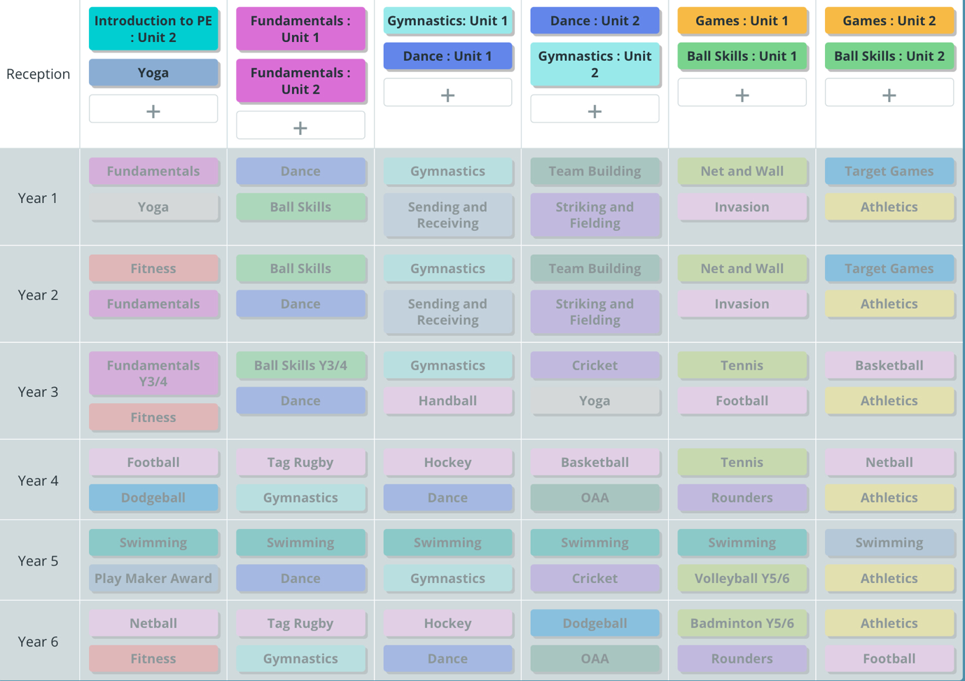

Appendix 2


