Oldswinford CofE Primary School


‘Believe, achieve and shine brighter together’

God is Love and at Oldswinford Church of England Primary School we believe that this love inspires us all to believe, achieve and shine brighter together.
We believe that there is a light which shines within each of us – a light of love that has been given to us by God, which we should use to help us achieve great things. We believe it is our job to help that light to shine in all that we do and all that we try to do.
The theology that underpins our vision is interlinked as we know we cannot achieve one without the other. With this guidance and belief in ourselves and God, we can and will achieve. At Oldswinford, we know we are not alone and by enabling our own lights to shine we empower others to do the same.

Our Approach to the Teaching and Learning of P.E.
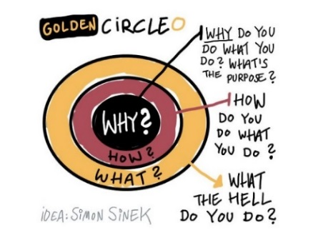

Subject Intent
Insert subject quote here
Why do we do what we do in this subject (aims)?
At OCEPS, we provide a high-quality physical education curriculum, which is inspiring to all pupils and encourages them to succeed and excel in competitive sport and other physically-demanding activities. We provide opportunities for pupils to become physically confident in a way which supports their health and fitness. This is important because opportunities to compete in sport and other activities help to build self-esteem, character and help to embed values such as fairness and respect. At Oldswinford CE Primary School it is recognised that PE needs to build on the children’s natural enthusiasm for movement, by expressing and testing themselves in a variety of situations. Through physical education we aim to enable pupils to develop co-ordination, strength, stamina and skilfulness and to promote spatial awareness, intelligent reactions to situations and appreciation of physical excellence. We believe that Physical Education should lead to a sense of wellbeing, a greater understanding of health and fitness, a healthy lifestyle and a feeling of self-confidence.
Subject Implementation

How do we ensure our intent becomes a reality?
OCEPS is a place where our teachers will carry out high quality lessons using the GetSet4PE scheme, providing opportunities for children to develop their skills. The children are then assessed at the end of each half term for their performance, social, emotional and thinking skills. This is done for each P.E. unit. At the end of each P.E. lesson, there is a plenary which encourages the children to reflect upon their performance and think about how the skills that they have learned can be transferred and applied in other subjects and in life. (See Appendix 1 for whole school overview) We carry out carefully sequenced units of work which build on prior learning and work to follow the learning journeys to ensure children progress, are challenged and that lessons are adapted to meet the needs of all children (See Appendix 2 & 3 for year group progression skills) We feel it is important to ensure everyone feels included and valued and that we develop children’s confidence, self-belief and resilience, as well as encouraging an ‘I can’ attitude. We always celebrate achievements, talents and those who are demonstrating resilience. Our P.E. lessons provide opportunities for children to communicate and work as part of a team and encourage children to, and set a good example of, leading healthy, active lives. This then helps to develop the children’s sense of responsibility towards their own and others safety and well-being.
Children are taught two hours of PE each week, throughout the year the children are given the opportunity to experience a variety of indoor and outdoor activities. Each class has hall time slots available for each P.E. session, so that even if the weather is poor, the children can still enjoy their P.E. lesson. At Oldswinford we expose the children to extra-curricular activities to broaden children’s opportunities to a variety of sports. Swimming lessons take place in Year 5 at the Crystal Leisure Centre, which is delivered by specialist swimming teachers. We also have coaches from local sports agencies who deliver lunchtime sessions and sports clubs throughout the week. Sports club sessions include, Multi-skills, dance, archery, rugby, basketball, cricket and many more, which alternate between year groups & which session is on offer. Children are offered a large variety of sports clubs to wider their experiences and develop a love for being active. Lunchtime clubs provide focussed activities for KS1 & KS2 with a regular different focus providing the children with a range of skill & game exposure. We are very privileged at Oldswinford as our Year 5 children work through the Playmaker Award. This certification enables them to experience how to teach sessions & deliver them with confidence. During the Spring term, our Year 5 P.E. Leaders (in small groups) then carry out lunchtime activities with the children & deliver P.E. lessons to children in KS1 helping them to develop their skills within P.E. unit.
Subject Impact
What are the outcomes for our children in this subject?
Through our carefully designed curriculum, children at Oldswinford will:
• Learn to communicate and work as part of a team.
• Develop competence to excel in a broad range of physical activities.
• Be given a broad range of opportunities to extend their agility, balance and coordination, individually and with others.
• Enjoy communicating, collaborating and competing with each other.
• Be physically active for sustained periods of time.
• Engage in competitive sports and activities.
• Develop flexibility, strength, technique, control and balance.
• Perform routines and compare them to improve and achieve their personal best.
• Be able to recognise their own success, as well as the success of others.
• Be a good team player and support their peers.
• Begin to learn to swim competently, confidently and proficiently.
• Lead healthy, active lives, with a good understanding of others and their well-being.
• Have fun!

Confidence
Well-being
Health
Teamwork
Communication
Success
Improve
Compete
Fun!
Achieve
Active

Support
Technique
Independence
Engagement

How do we know that we have achieved these outcomes?
We know that we have achieved these outcomes if the children have shown progress throughout the lesson and developed a skill. Assessments are carried out by class teachers at the end of each half term for each unit of P.E. covered, using the progression documents. This is recorded through the GetSet4PE scheme, which tracks, performance, social, emotional and thinking skills.
Whilst teachers are carrying out P.E. lessons they are persistently assessing the children’s skills and making adaptations to help support the children. Photographs and videos are also taken during the lesson to show the children’s abilities.
Plenaries take place at the end of each lesson to ensure the children have understood their learning objectives, as well as their social, emotional and thinking objectives. This time also allows for the children to reflect and think deeper about what skills they have developed, why they are important and how they can be transferred to other learning and in their life.
The children are regularly asked about their P.E. lessons, allowing them to use their pupil voice to impact their learning.

Appendix 1
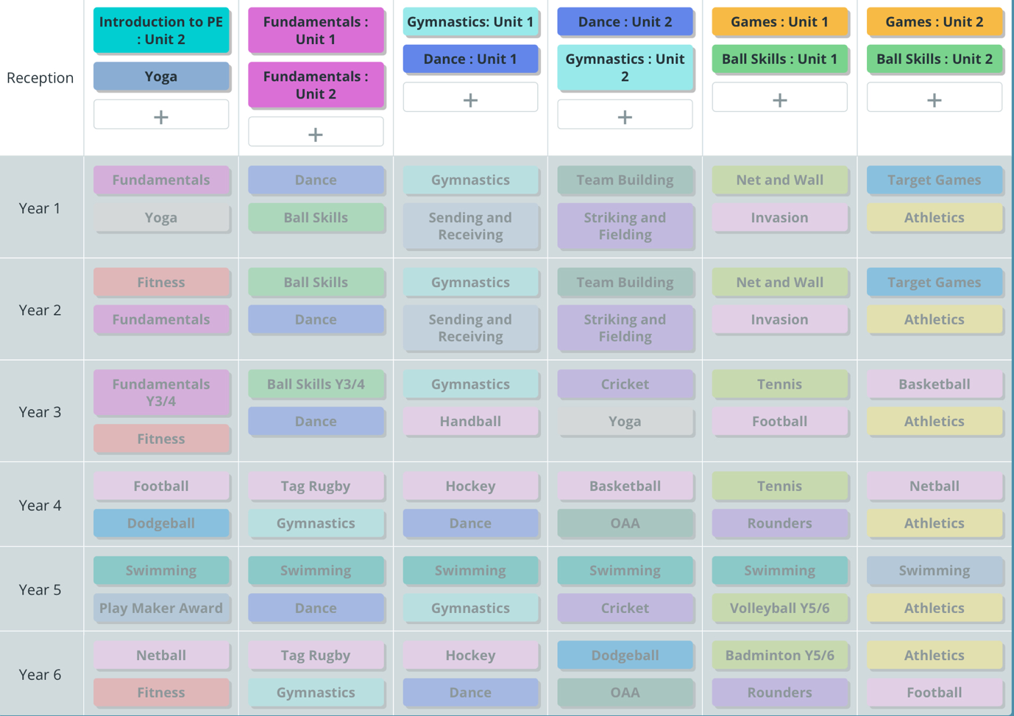
Whole School P.E. Overview

Appendix 2 –
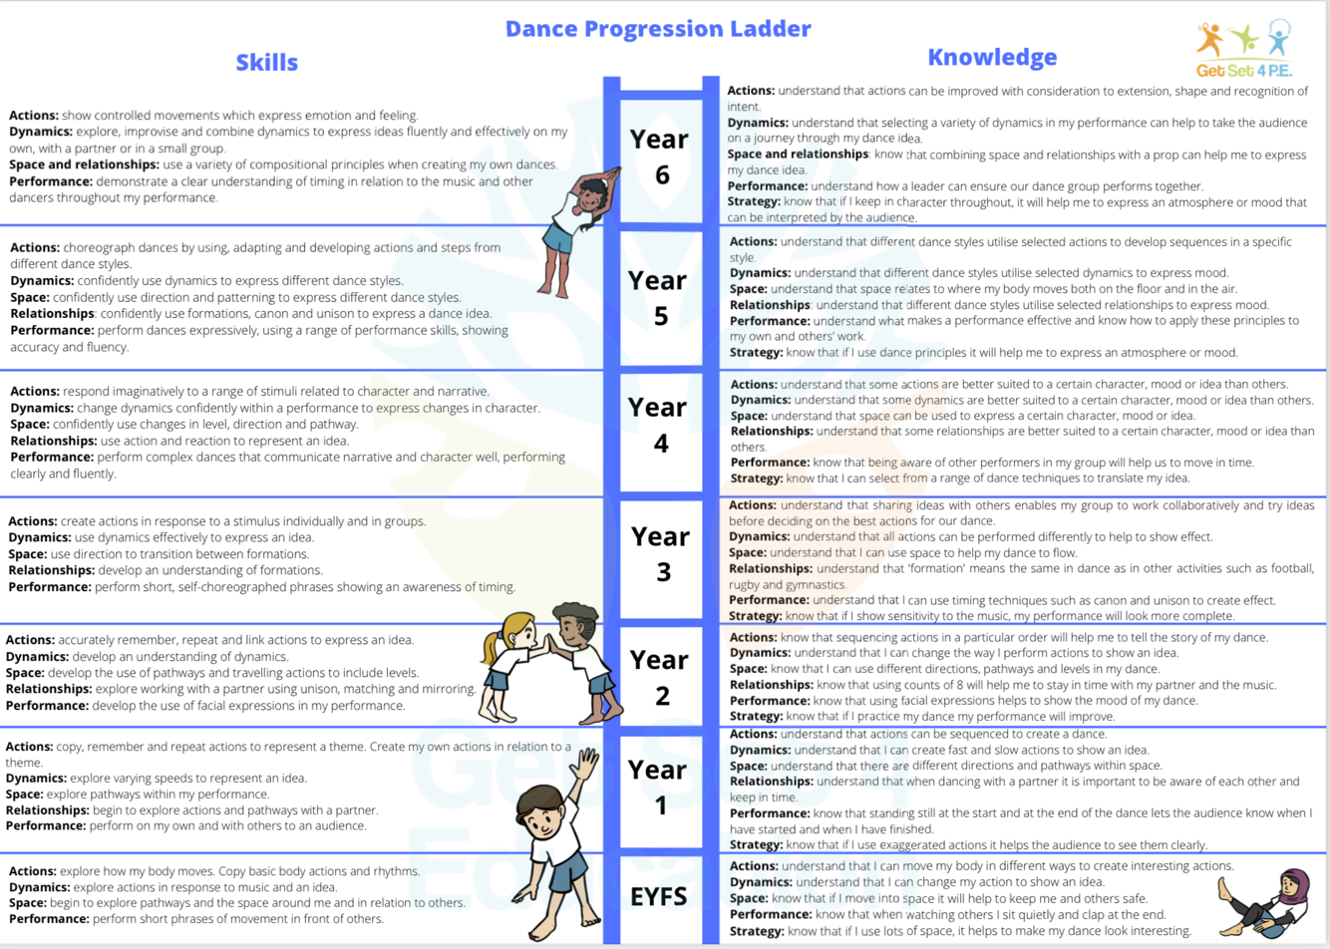
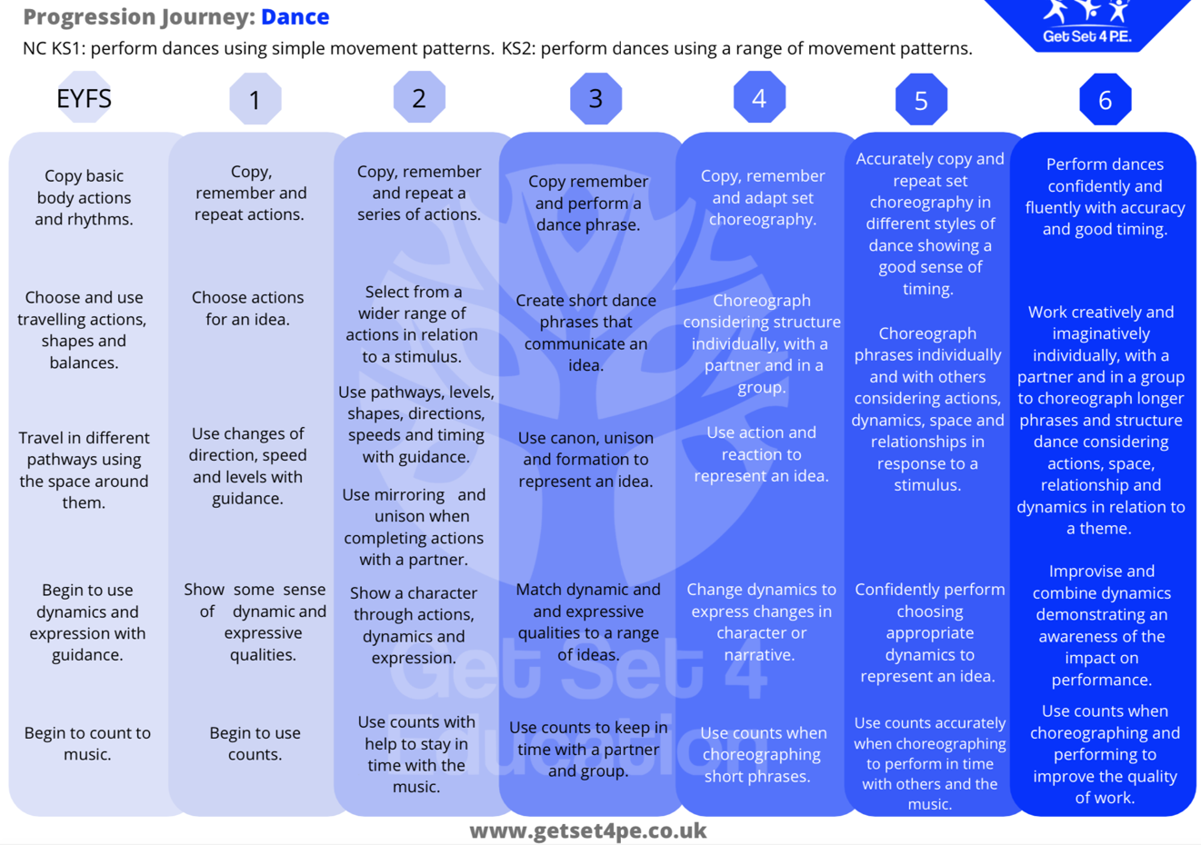
An example Progression document

